Nama : Nabila marcha

Kelas : MI3A

NIM : 09010282327033

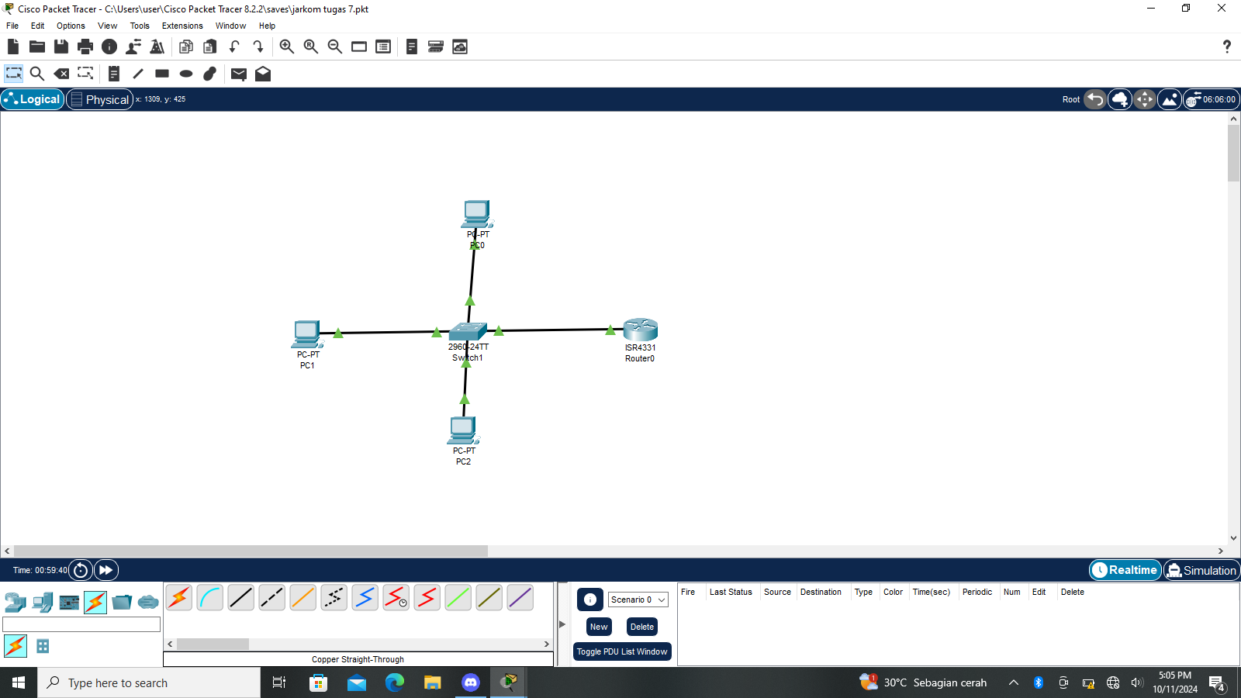TUGAS PRAK JARKOM

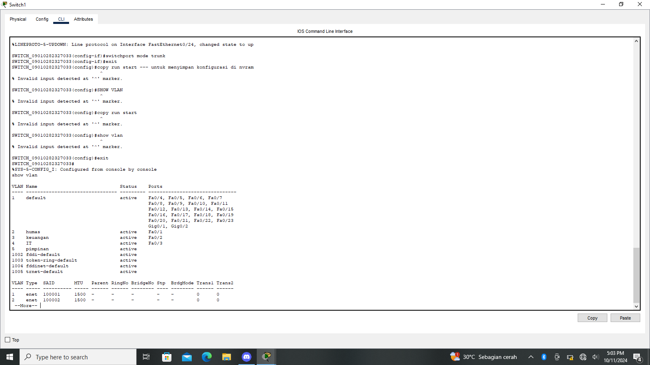

|  |  |  |  |
| --- | --- | --- | --- |
| VLAN | nama | status | port |
| 1 | Default | Active | Fa0/4, Fa0/5, Fa0/6, Fa0/7  Fa0/8, Fa0/9, Fa0/10, Fa0/11  Fa0/12, Fa0/13, Fa0/14, Fa0/15  Fa0/16, Fa0/17, Fa0/18, Fa0/19  Fa0/20, Fa0/21, Fa0/22, Fa0/23  Gig0/1, Gig0/2 |
| 2 | Humas | Active | Fa0/1 |
| 3 | Keuangan | Active | Fa0/2 |
| 4 | IT | Active | Fa0/3 |
| 5 | Pimpinan | Active | - |

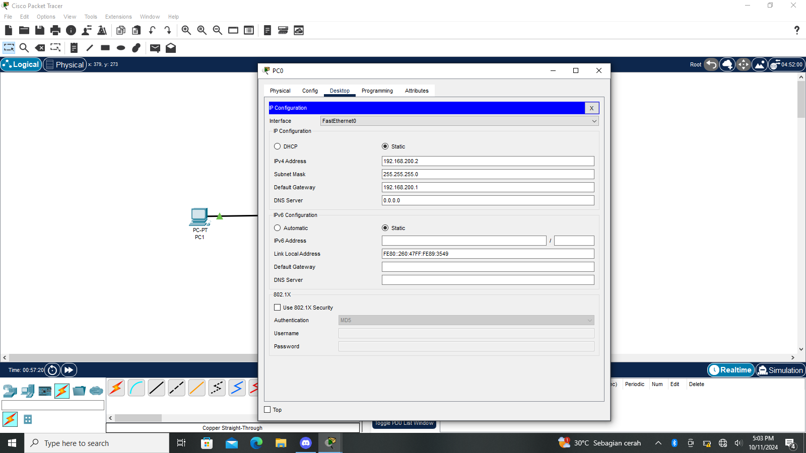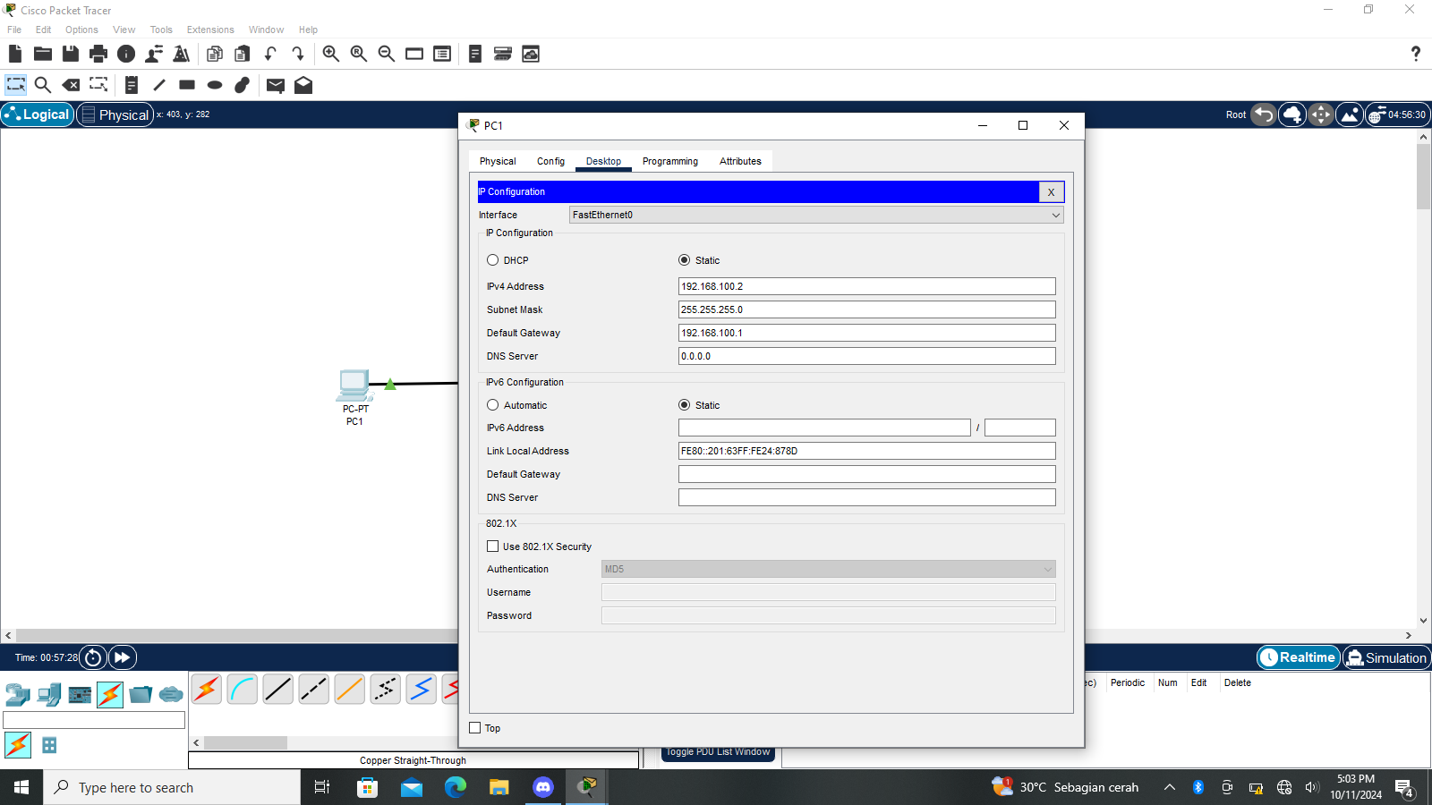

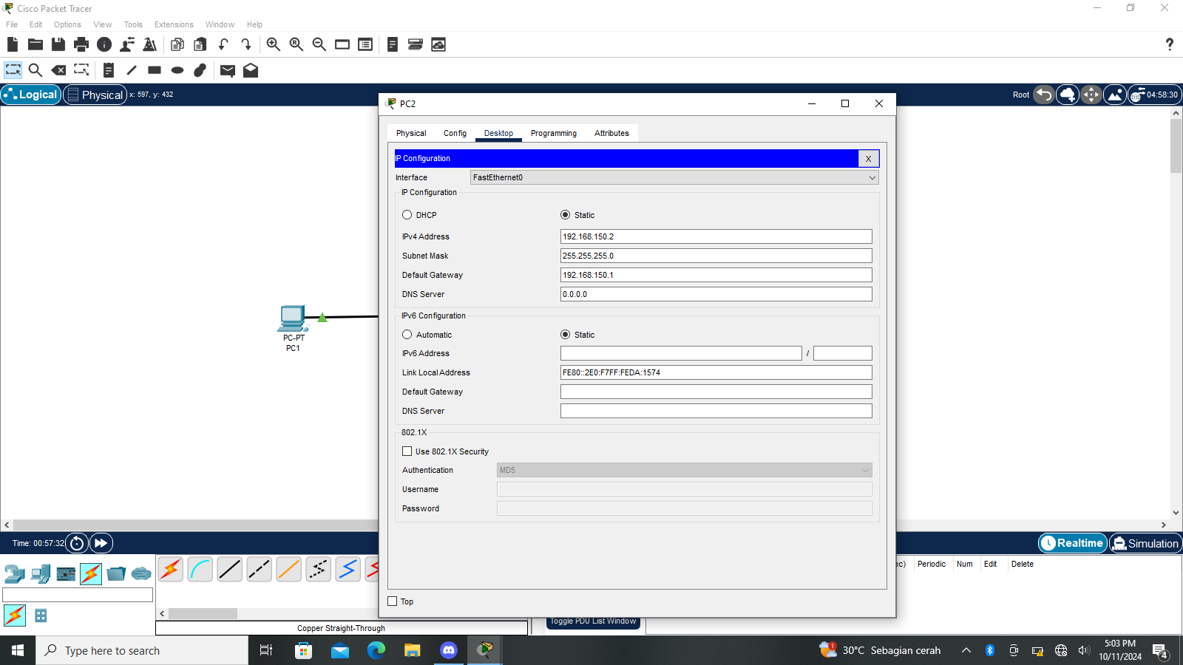

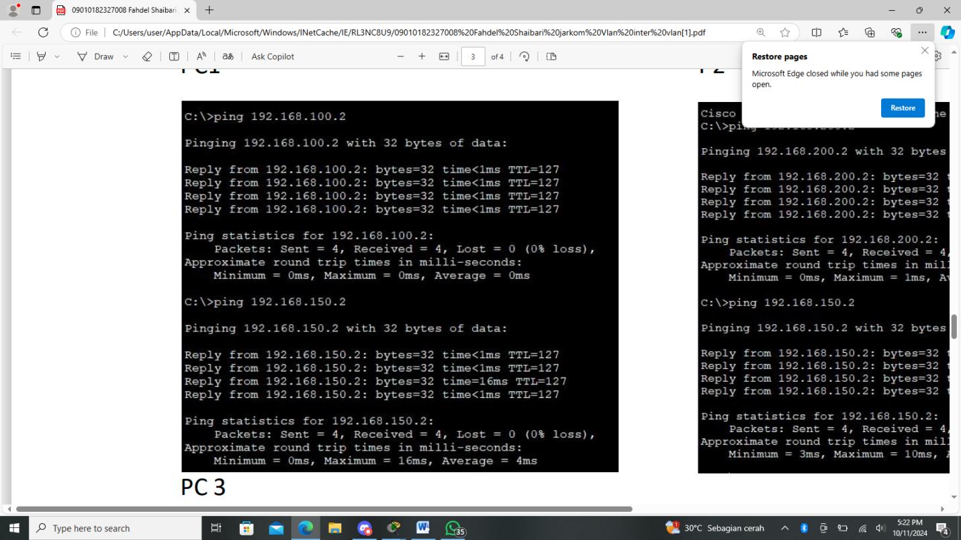PC 1

PC 2

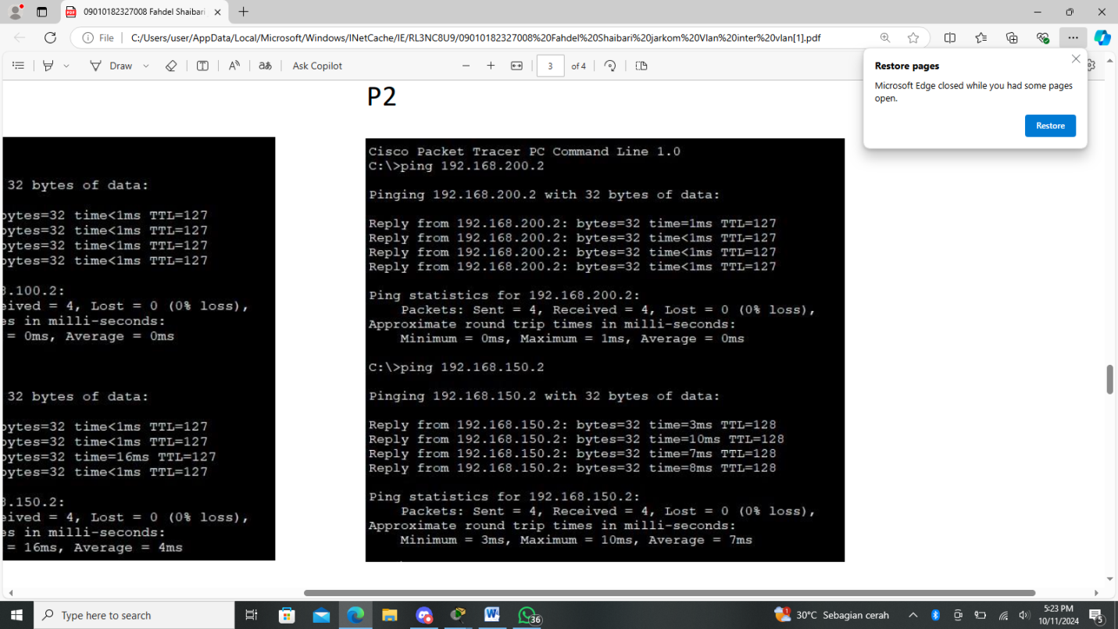

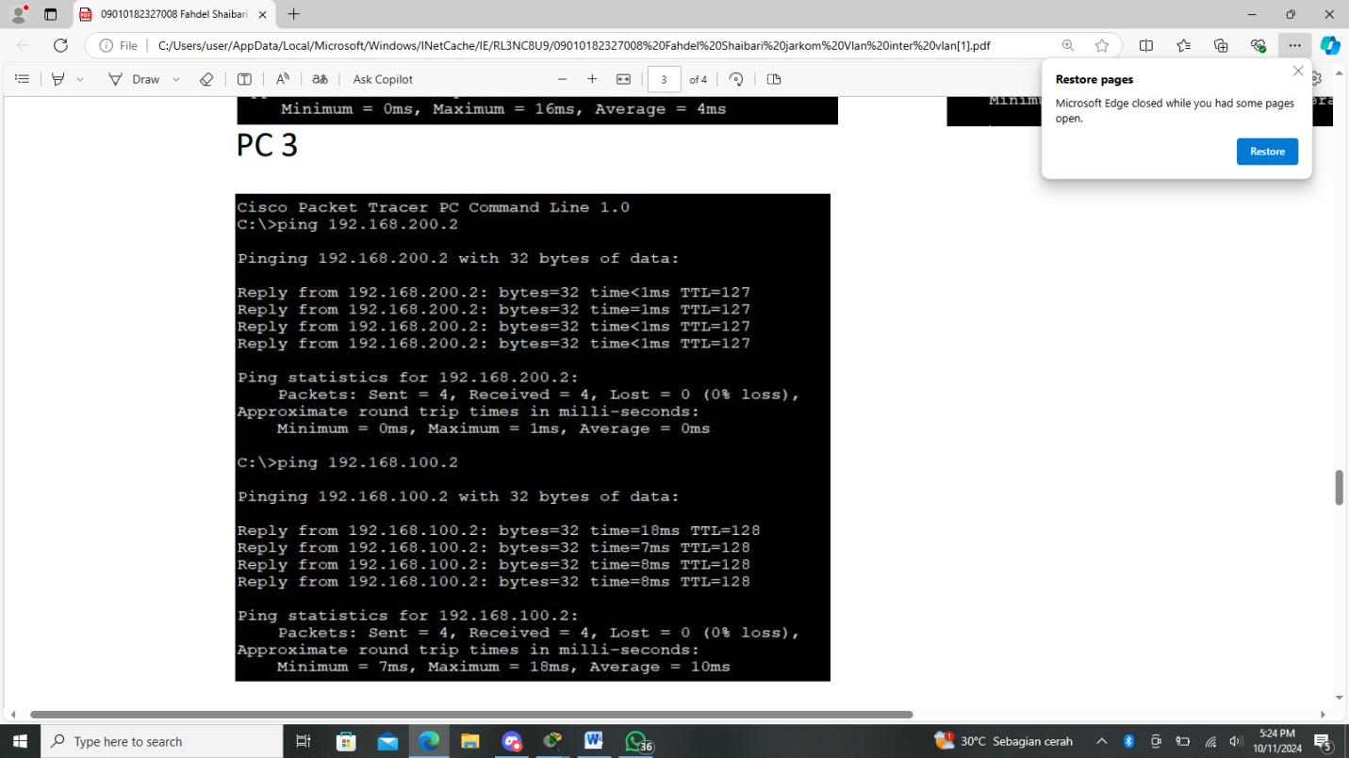PC 3